Terraform Installation Guide

Our first task is to install Terraform. To do this on Windows, let's download the latest binary from here: https://developer.hashicorp.com/terraform/downloads:
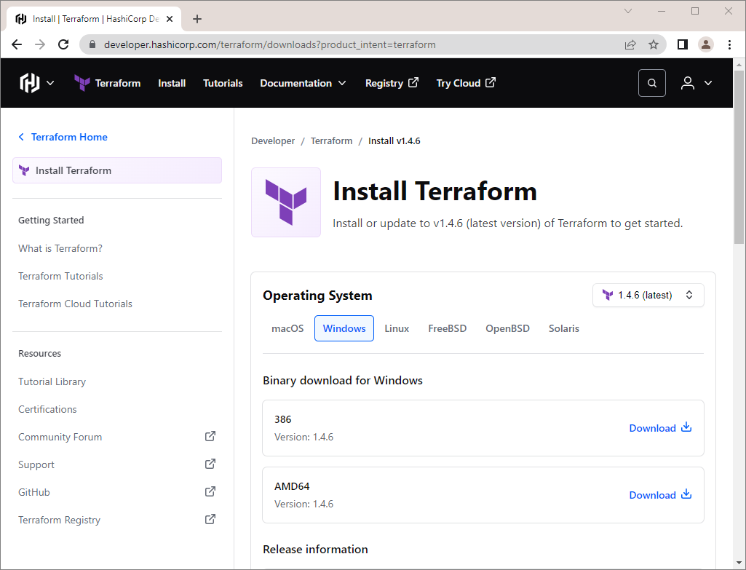
You have downloaded a .zip file, which you should unzip:
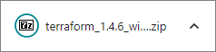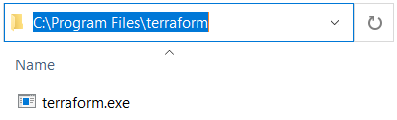
Terraform runs as a single binary named terraform.exe. Any other files in the package can be safely removed and Terraform will still function.
Now you should add the path to the binary in the PATH environment variable. To do this, copy the file path and go to "View advanced system settings" by searching for it or through the Control Panel:
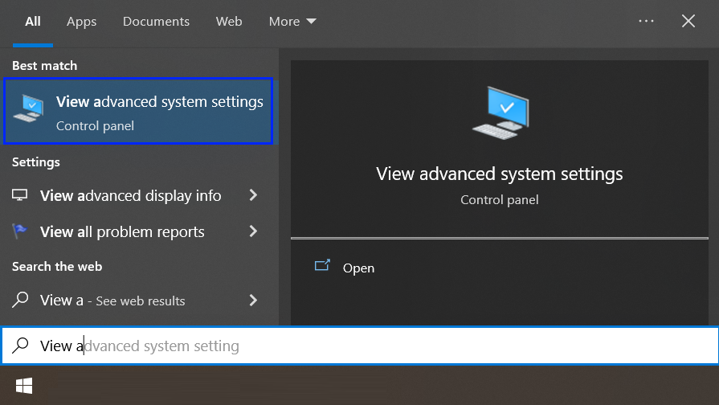
You should see the "System Properties" window and click on [Environment Variables]:
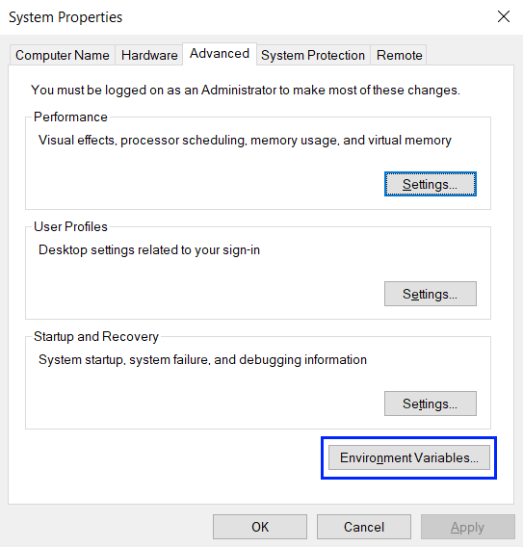
Next, click on the "Path" variable and on the [Edit] button:

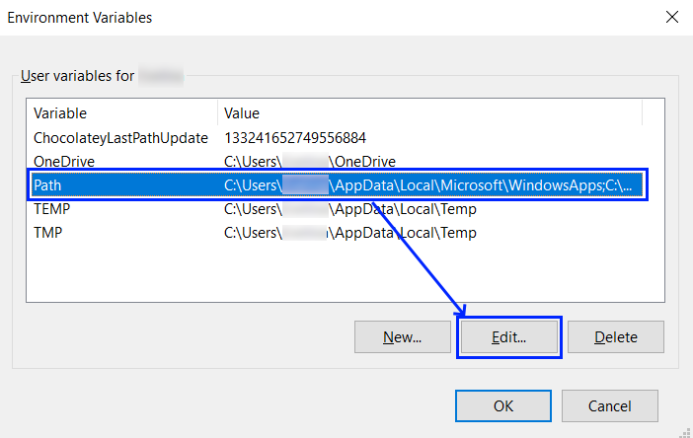
Then you should press the [New] button and add the path to where the terraform.exe file is:
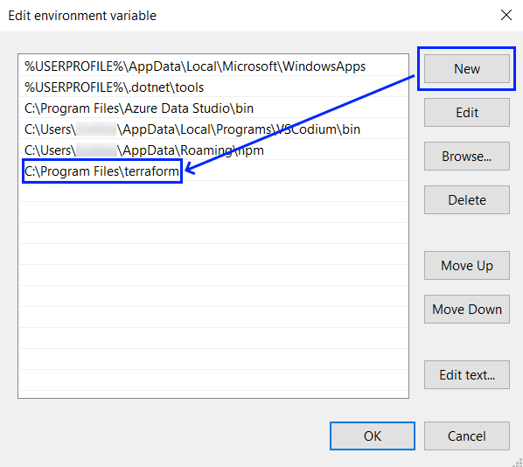
Click consecutively on [OK] buttons to exit all settings. At the end, let's open a terminal and test if Terraform is installed with the terraform -help command that lists all available commands:
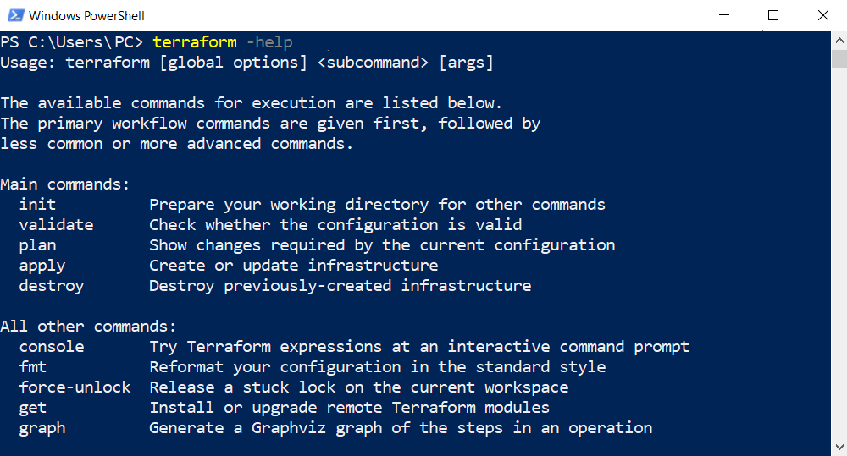

If you receive any error, it is probable that your PATH environment variable was not set properly.
Otherwise, you now have Terraform and you can go on with fulfilling the next tasks of this exercise.

